PROJECT TITLE : CLIENT MANAGEMENT SYSTEM OF LAND REAL ESTATE SYSTEM
STUDENT NAME: OCHOM MARCUS ETHINE
GROUP NO:9
REG NO: 2025/BCS/153/PS
STUDENT NO:
COURSE UNIT: DATABASE SYSTEMS
COURSE CODE: CSC 1204
INSTITUTION: MBARARA UNIVERSITY OF SCIENCE AND TECHNOLOGY
FACULTY: COMPUTING AND INFORMATICS
PROGRAM: COMPUTER SCIENCE
SUBMISSION DATE: 07/05/2025

CLIENT MANAGEMENT SYSTEM
- Executive Summary
This report presents the business case for developing a Client Management System (CMS) for a real estate company specializing in land sales. The system is designed to streamline client interactions, manage property listings, track sales transactions, and improve overall operational efficiency.
Currently, many real Estate land sales businesses rely on manual record-keeping or fragmented digital tools, which leads to inefficiencies, data inconsistencies, and poor customer service. The proposed CMS will centralize all client and sales data into a structured database system, enabling better decision-making, improved customer relationships, and increased revenue.
I developed this database using MYSQL which performs basic data management tasks such as insertion, modification, and deletion of data from the relations. It also incorporates tables, relationships and sample queries for effective data management.
The report evaluates the application domain, benefits, costs, user considerations, risks, and system limitations to determine the feasibility and value of implementing the system.

- Business Case
The purpose of the system is to solve multiple client problems such as land ownership disputes and it is also designed to focus in managing client relationships and interactions
2.1 Application Domain
The proposed system operates within the real estate sector, specifically focusing on land sales management.
The CMS will support the following operations:
- Client registration and profile management
- Land listing and tracking and inquiring
- Document management (agreements, titles, contracts)
Target Users
The system will generally target the following users;
- Real estate agents
- Sales managers
- Administrative staff
- Company management

  - Analysis of Benefits
The system has got benefits both tangible and intangible
Tangible Benefits
- Improved efficiency: Faster access to client and property data
- Reduced paperwork: Digital storage replaces manual files
- Increased sales tracking accuracy
- Better reporting: Sales trends, revenue, and client insights
- Time savings: Automation of repetitive tasks

Intangible Benefits
- Enhanced customer satisfaction due to faster service
- Improved decision-making through accurate data
- Professional image of the company
- Better communication between staff and clients
- Data security and integrity

  - Analysis of Costs
The system has also got costs that are both tangible and intangible
Tangible Costs
- Hardware (computers, servers)
- Development time and labor
- System maintenance and updates are expensive
Intangible Costs
- Staff training
- Resistance to change from employees
- Time spent transitioning from old systems

2.4 User Issues
Skills Required
- Basic computer literacy
- Ability to use database-driven interfaces
- Minimal training on system navigation
Adoption Challenges
- Resistance from staff used to manual systems
- Learning curve for new users

2.5 Risk Assessment
Technical Risks
- System bugs or failures
- Data loss or corruption
- Integration issues
Organizational Risks
- Resistance to system adoption
- Poor data entry practices
External Risks
- Cybersecurity threats
- Power or network failures

Risk Mitigation
- Regular backups
- System testing before deployment
- User training
- Security measures (authentication, access control)

2.6 Limitations of the System
- Limited scalability if not designed properly
- Dependence on technology (system downtime affects operations)
- Requires continuous maintenance and updates
- May not fully eliminate human errors (e.g., incorrect data entry)
- Initial implementation may be time-consuming

- Database design based on requirements
Local design
- List of entities
- Client
- Inquiry
- Ownership
- Plot
- Entities and Attributes
- Client: ClientID, FirstName, LastName, Phone, Email, ClientType
- Inquiry: InquiryID, ClientID, PlotID, InquiryDate, InquiryStatus
- Plot: PlotID, Location, Size, Price
- Ownership: ClientID, OwnershipID, OwnershipStatus, ClientID, PlotID, TitleStatus

- Entity Relationships
Client and Inquiry
- Relationship: One-to-Many (1:N)
- Description: A single Client can make multiple Inquiries about different properties over time. However, each specific Inquiry is linked to exactly one Client.
- Foreign Key: Client_ID typically resides in the Inquiry table to maintain this link.
2. Plot and Inquiry
- Relationship: One-to-Many (1:N)
- Description: One Plot (land parcel) can be the subject of many different Inquiries from various potential buyers. Conversely, a single inquiry record is usually focused on one specific plot.
- Foreign Key: Plot_ID resides in the Inquiry table.
3. Client and Ownership
- Relationship: One-to-Many (1:N)
- Description: A Client can hold Ownership of multiple plots. While a single ownership record identifies one specific owner, a person (Client) can appear in the ownership registry multiple times for different assets.
- Foreign Key: Client_ID is used in the Ownership table to identify who owns the property.
4. Plot and Ownership
- Relationship: One-to-One (1:1) or One-to-Many (1:N)
- Description: In a standard registry, a specific Plot has one current active Ownership record. If the system tracks historical data, this becomes a $1:N$ relationship where one plot has many ownership records over time, but only one is "active."
- Foreign Key: Plot_ID resides in the Ownership table.

- A comprehensive ERD for my database
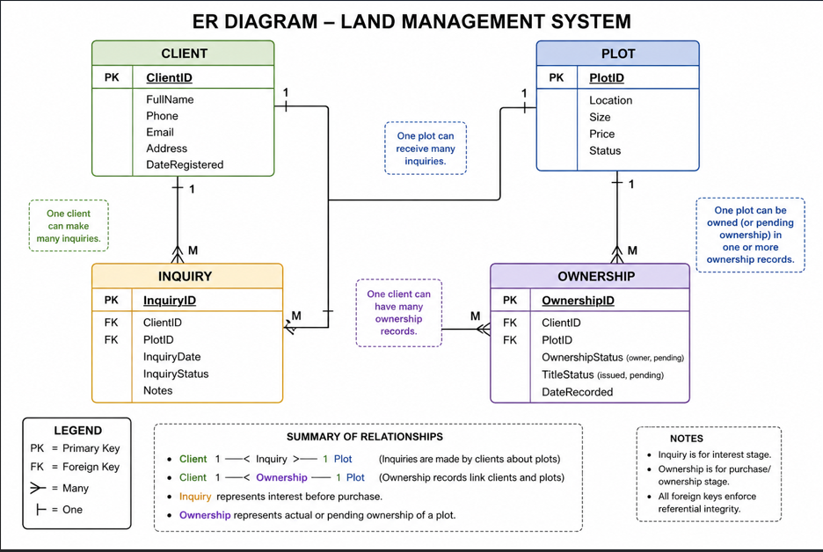

THE PHYSICAL DESIGN;
DATABASE SCHEMA;
Table Name | Attributes | Primary key | Foreign key
Client | ClientID, firstName , lastName , email, phone, clientType | ClientID
Plot | PlotID, location, size , price | PlotID
Inquiry | InquiryID , ClientID, PlotID, InquiryDate, InquiryStatus | InquiryID | ClientID, PlotID
Ownership | OwnershipID, OwnershipStatus, PlotID, ClientID, TitleStatus | OwnershipID | ClientID, PlotID

PHYSICAL DESIGN
The following SQL code is the implementation of the client management system that creates tables for the entities above.
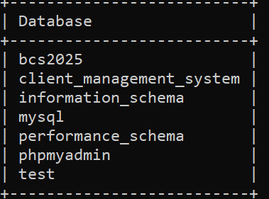
The implementations below show the code for the relations created;
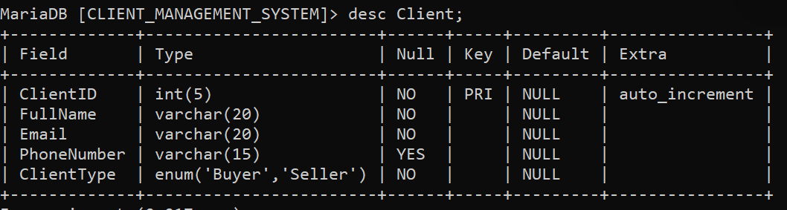
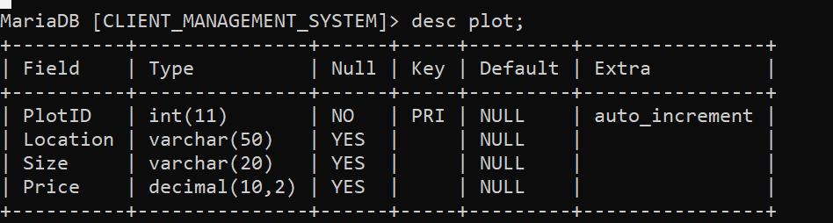
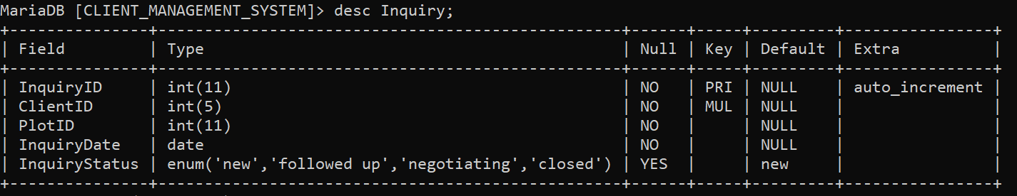
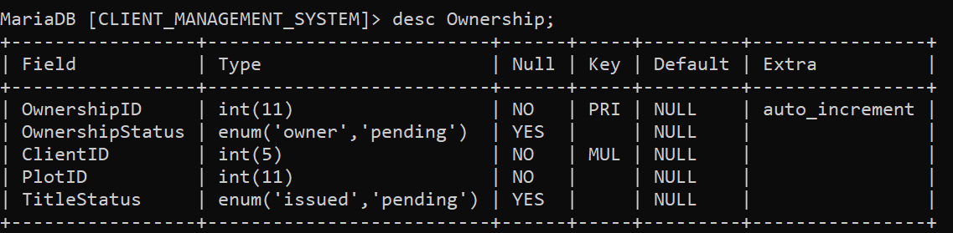
The implemented code below shows the tables with inputed data and sample queries
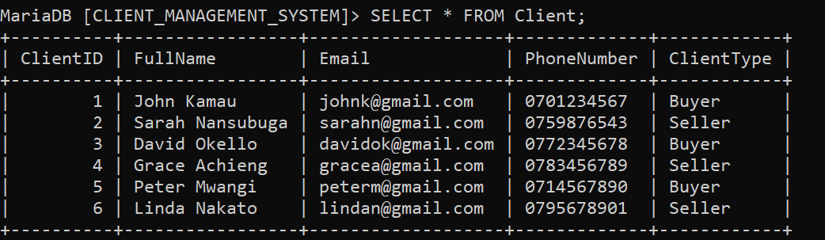
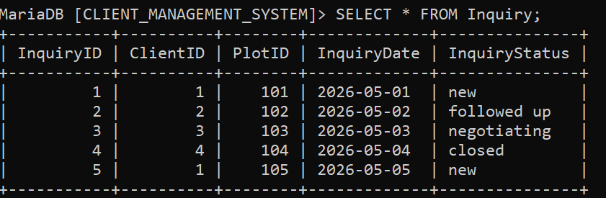
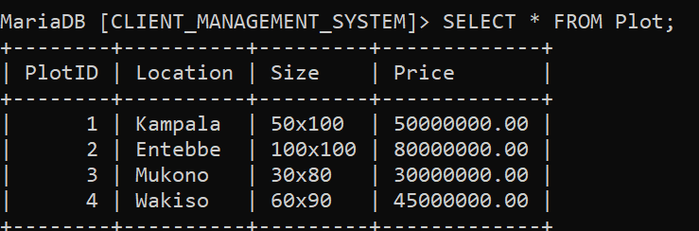

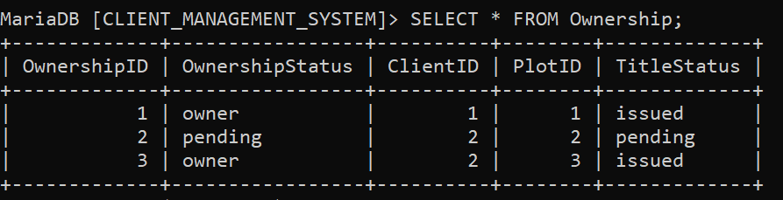
More sample queries and their results
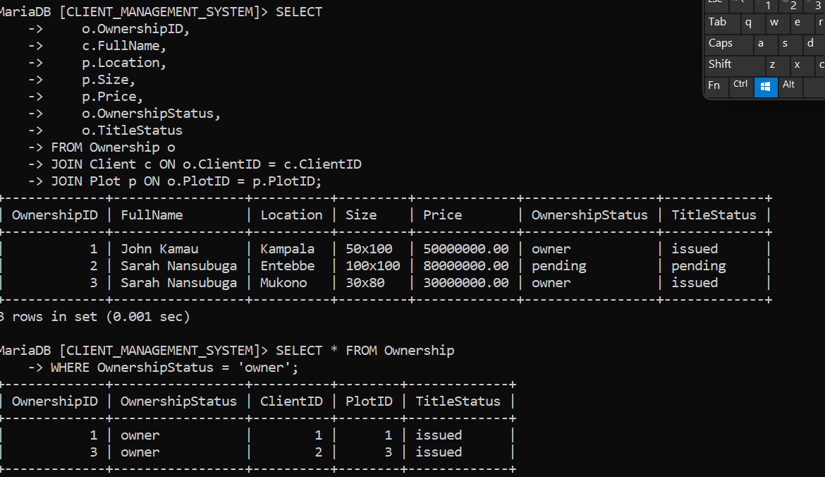

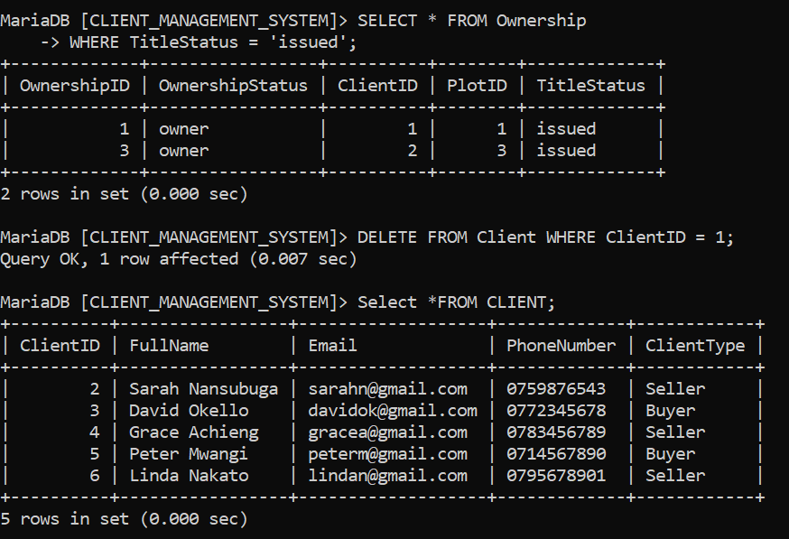

Conclusion
The development of the Land Client Management System demonstrates a comprehensive approach to digitizing the complexities of real estate data management. By following the structured methodology of requirement analysis, logical design, and physical implementation, the project successfully translated real-world business needs into a functional relational database.

Bibliography
❖ MySQL Documentation: https://dev.mysql.com/doc/
❖ A Practical Approach to Design, Implementation, and Management Sixth edition by Thomas Connolly Carolyn Begg
❖ Eclipse Foundation. (2025). Eclipse IDE for Java Developers. Retrieved from https://www.eclipse.org/
❖ Database design tutorials from W3Schools.

